Password Cracking with John the Ripper

Aim: This document describes the process of using John the Ripper to crack a list of hashed passwords.

**Process:**

1. Creation of list of passwords

2. Hashing the passwords

3. Saving them in the run directory of JohnTheRipper

4. Cracking the passwords using John The Ripper in cmd using some commands.

**Files Used:**

1.'passwords.txt': A wordlist of potential passwords.

2.'hashed_passwords.txt': Contains the hashed passwords to be cracked.

**Commands Used:**

1.Changing the directory: C:\JohnTheRipper\run>

2.Cracking command: john --wordlist=passwords.txt --format=Raw-SHA512 hashed_passwords.txt

3.Show command: john --show hashed_passwords.txt

**OUTPUT:**

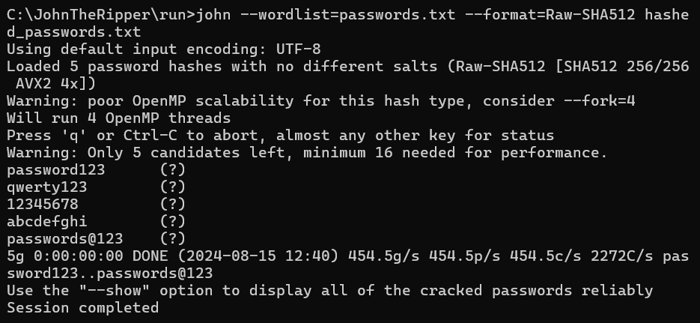

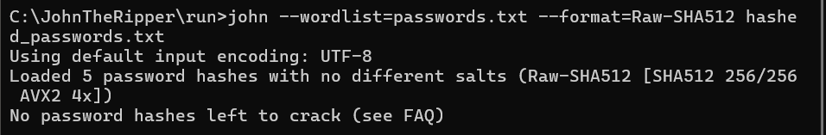

**Result:**

John the ripper successfully cracked all the passwords. In the line 0:00:00:00 DONE, the 0:00:00:00 indicates the time taken to crack the password in the format **days: hours: minutes: seconds.**

* **200.0g/s**: The speed of guessing passwords in guesses per second.(Guessed all 5 passwords)
* **600.0p/s**: The number of passwords attempts per second.
* **600.0c/s**: The number of hashes per second.
* **1200C/s**: Total number of passwords processed per second.